Teacher screenshot

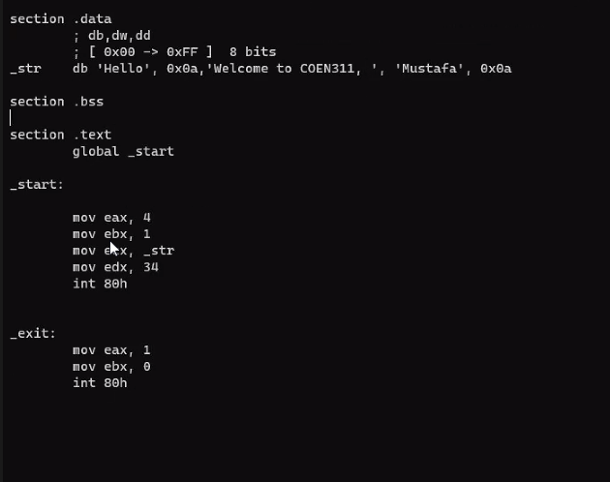

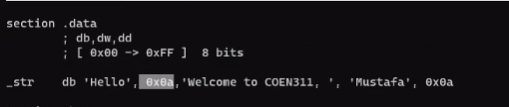

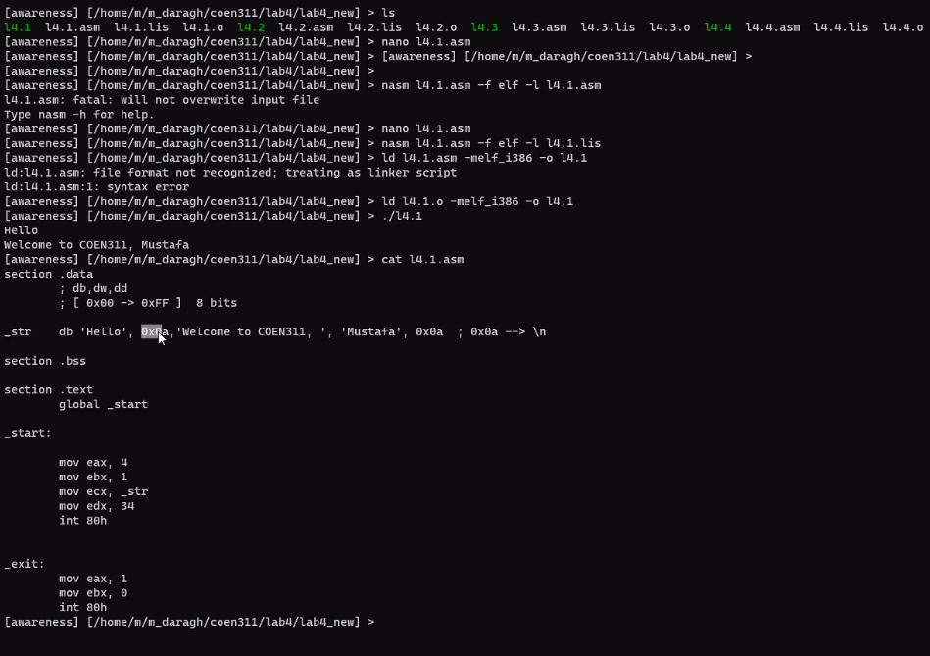

Int 80h is like a loop, with edx being the control

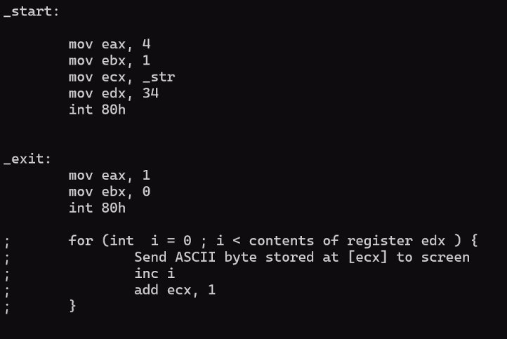

IF = internal flag

PF = parity flag (is here when there is EVEN of 1’s)

ZF = zero flag (set to 1 if the result is equal to zero)

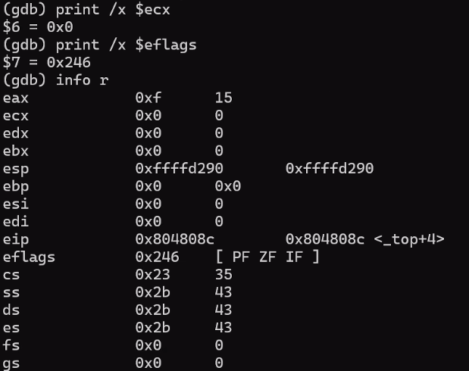

Out of loop, result is “15”

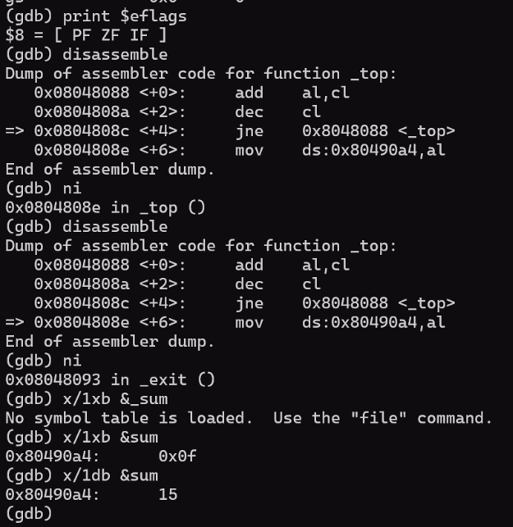

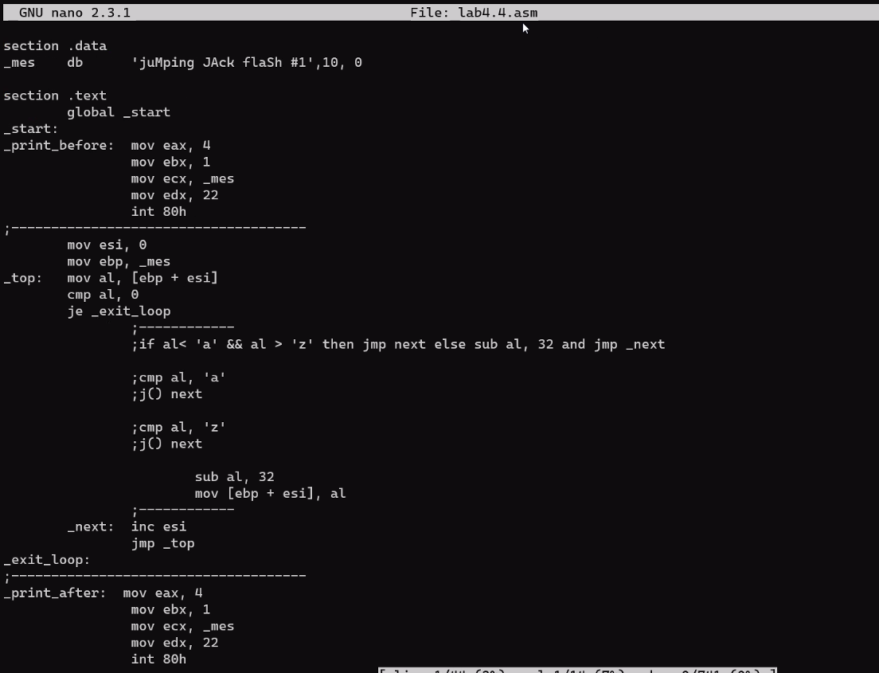

section .data_mes db 'juMping JAck flaSh #1',10, 0section .text global _start_start:_print_before: mov eax, 4 mov ebx, 1 mov ecx, _mes mov edx, 22 int 80h;------------------------------------- mov esi, 0 mov ebp, _mes_top: mov al, [ebp + esi] cmp al, 0 je _exit_loop ;------------ ;if al< 'a' && al > 'z' then jmp next else sub al, 32 and jmp _next ;cmp al, 'a' ;j() next ;cmp al, 'z' ;j() next sub al, 32 mov [ebp + esi], al ;------------ _next: inc esi jmp _top

_exit_loop:

;-------------------------------------

_print_after: mov eax, 4

mov ebx, 1

mov ecx, _mes

mov edx, 22

int 80h

_exit: mov eax, 1

mov ebx, 0

int 80h